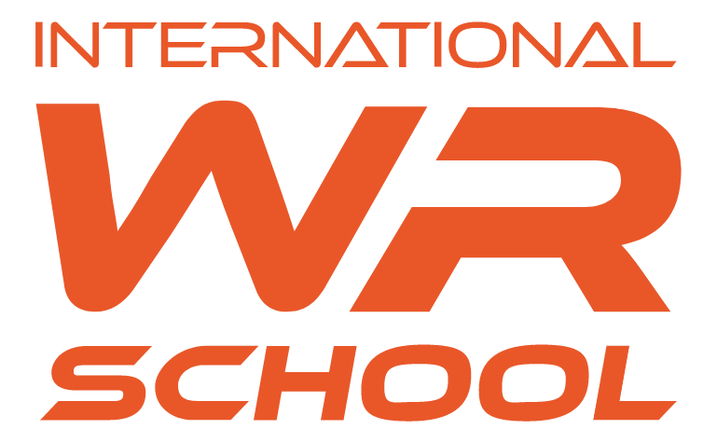
PAYMENT REGULATIONS
International WR Early School in Świlcza
for the 2026/2027 School Year

Monthly tuition fees payable in 12 instalments | PLN 2 000.00
One-off registration fee* | PLN 1 000.00
Alior Bank account number | 79 2490 0005 0000 4530 0028 2288
*The registration fee covers the formalities related to the admission of the child and the cost of preparing a place for the preschooler to work, and is non-refundable, even if the child does not qualify for preschool.
When enrolling siblings, the school provides a discount on the tuition fee of:
- For two children, the tuition is reduced by 10% for the second child,
- For three children it is reduced by 15% for the third child.

The tuition fee includes:
- implementation of Polish and British Cambridge International Education core curriculum,
- swimming pool 1x a week,
- Spanish 2x a week,
- Cambridge subjects:
- English as a second language 1x per week;
- Science 1x a week,
- general sports activities 2x a week,
- corrective gymnastics 1x a week,
- eurhythmics 2x per month,
- activities with modern technology (computer room, squash court with advanced interactive system)
- exclusive use of the most modern facility in Europe,
- the facility is open from 1.09 to 31.08 from 7:00 a.m. to 5:00 p.m.
- care provided by a psychologist, educationalist and school hygienist
- environmental education.
The tuition fee does not include:
- textbooks and exercise books
- language and Cambridge textbooks
- excursions
- insurance
- meals
- art equipment
- extracurricular activities

